St Lawrence College, School of Business

Graduate Certificate Program, Business Analytics

**ADMN5003: Data Acquisition, Analysis and Modelling Techniques (Fall 2022)**

Assignment 1 – Due on Friday, September 23rd, 2022 @ 2:00pm

12 Marks

* Open book assignment.
* You need to submit your assignment to Blackboard in a group of 2 students.
* Submit a Word file with the file name in this format: Assign1_First name1_First name2.
* Late submission penalty is 10% per day.

**Data Mining for Business Analytics text (The Green Book)**

1. Problems 2.1 a, b, c, d, e, f, g, h (4 marks, 0.5 mark each)

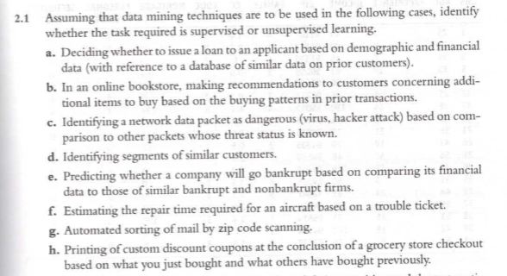

1. Problem 2.8 (show calculation steps for each column, Age and Income) (4 marks)

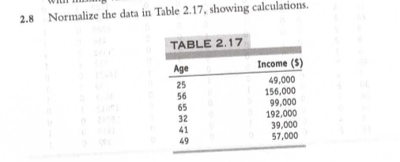

1. Problem 2.10 (1 mark)

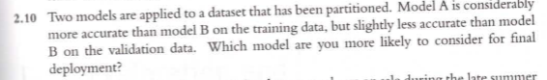

**Data Science and Big Data Analytics text (The Black Book)**

1. Chapter 3 Problem 1 (0.5 mark)
   1. 3 levels
2. Chapter 3 Problem 2 (0.5 mark)
   1. A picture containing text, scoreboard

      Description automatically generated
   2. A screen shot of numbers

      Description automatically generated with low confidence
3. Chapter 3 Problem 4 (0.5 mark)
   1. Install.packages
4. Chapter 3 Problem 5 (0.5 mark)
   1. factor

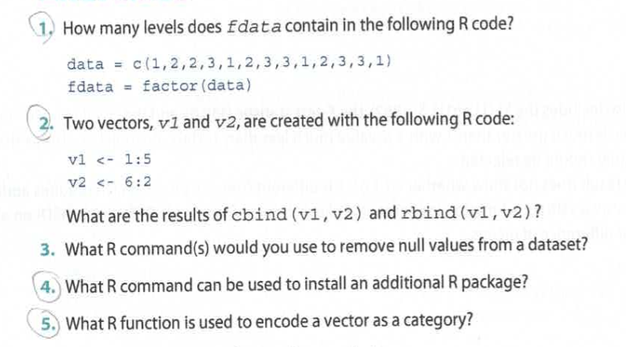

1. Short answer: State the difference between a matrix and a data frame in R (0.5 mark).
2. Short answer: List the basic data types in R (0.5 mark).